A N G E R
the Jesus Way
Will ANGER visit you over the holidays?

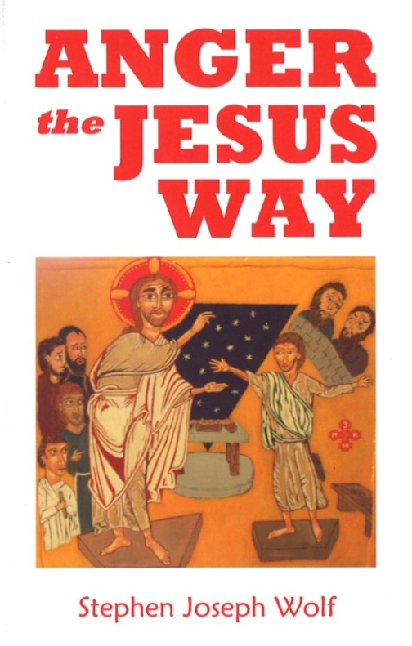
Fr. Steve Wolf will be offering this class using his revised book
ANGER the JESUS WAY
following Mark 3:1-6, the only place where the gospel writers use
the word “anger” to describe Jesus:
…looking around at them with ANGER
and grieved at their hardness of heart…

We will examine together
the life-changing way Jesus models
to deal with and pray about ANGER.

November 27, December 4, December 11
(in Advent 2016)
Three Sundays from 6:45 pm to 8:15 pm

Immaculate Conception Church
St. Joseph Room
at 709 Franklin Street Clarksville, TN 37040
An rsvp is appreciated at (931) 645-6275 or etc@idjc.org
so we can be sure to have materials ready.

