PONDERING ETC

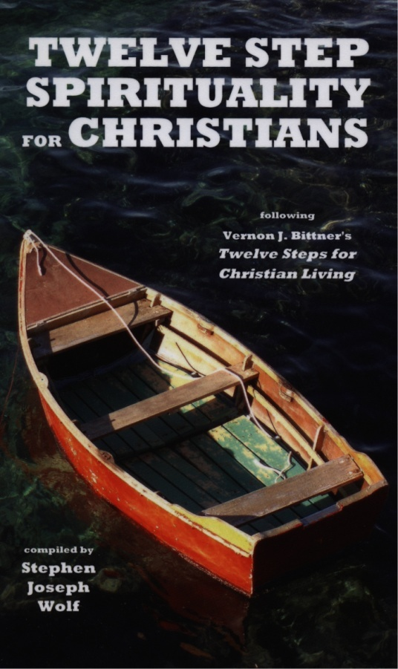
sharing our stories of faith
at the intersection of
Experience, Tradition, & Culture

Groups of 8 - 10 people
gathering in parishioners homes
once a week for 90 minutes
for the six weeks this Fall.

Participants will receive a copy of
TWELVE-STEP SPIRITUALITY
FOR CHRISTIANS
by Rev. Steve Wolf

Meetings start the week beginning Sunday October 2, 2016
and conclude the week ending Saturday November 12, 2016.

SIGN UP SUNDAYS: September 17-18 and 24-25
in the NARTHEX
FALL 2016
Or to sign up for a group contact Carol Nichols
at nich2catec@aol.com or (931) 552-7772
with the best time of day and/or
the best day of the week for you.

Questions? Contact Rev. Steve Wolf
at etc@idjc.org or (931) 645-6275, ext. 102.
Immaculate Conception Church
709 Franklin Street, Clarksville, TN 37040

