IC PONDER GROUPS

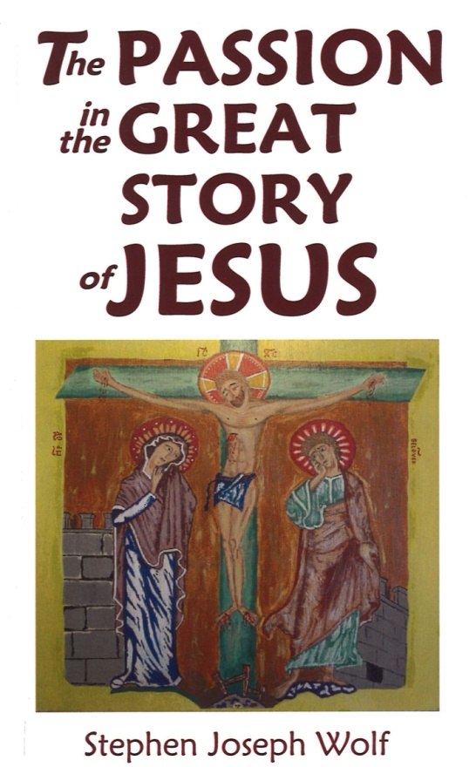
An IC Ponder Group is 8 - 10 people
gathering in parishioners homes
once a week for 90 minutes
for the six weeks of Lent.

We will ponder side-by-side the four Passion Narratives over six weeks:

1. ARREST 3. PILATE 5. DEATH
2. SANHEDRIN 4. CROSS 6. BURIAL

← Participants will receive a copy of the book and are asked to bring a Bible to the meetings.

All are also welcome to Fr. Steve’s introduction
to The Passion in the Great Story of Jesus
for Ponder Group Hosts & Leaders on
Sunday February 12 at 4:00 pm in the Chapel.

Meetings start the week beginning Sunday February 26, 2017
and conclude the week ending Saturday April 9, 2017.

SIGN UP SUNDAYS: February 11-12 & February 18-19
in the NARTHEX
LENT 2017
Or to sign up for a group contact Carol Nichols
at nich2catec@aol.com or (931) 552-7772
with the best time of day and/or
the best day of the week for you.

Questions? Contact Rev. Steve Wolf
at etc@idjc.org or (931) 645-6275, ext. 102.
Immaculate Conception Church
709 Franklin Street, Clarksville, TN 37040

IC PONDER GROUPS
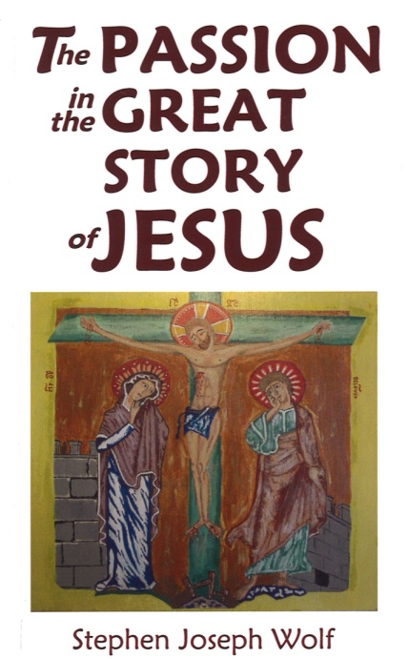
Weeks of February 26 thru April 9, 2017
These weekdays & times would work best for me:
Days of the Week Time of the Day
1st __________ _______________
2nd __________ _______________
3rd __________ _______________
4th __________ _______________
Name:_______________________
Address:_____________________
Phone:______________________
Email:______________________
__I am able to host. __I am able to lead.

IC PONDER GROUPS
Weeks of February 26 thru April 9,2017
These weekdays & times would work best for me:
Days of the Week Time of the Day
1st __________ _______________
2nd __________ _______________
3rd __________ _______________
4th __________ _______________
Name:_______________________
Address:_____________________
Phone:______________________
Email:______________________
__I am able to host. __I am able to lead.

