BEING SPOUSES Join Fr. Steve Wolf for a Friday Night and Saturday Retreat for Married & Engaged Couples

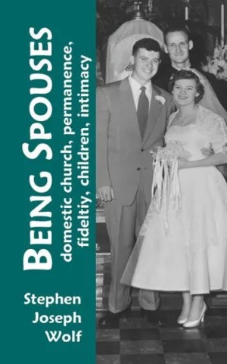
Six Aspects of MARRIAGE:

1 Marriage Sacramentality
2 The Domestic Church
3 Permanence
4 Fidelity
5 Children
6 Intimacy

plus some insights
from Pope Francis
in The Joy of Love
(Amoris Laetitia)

Friday July 21, 2017 6:00 pm to 8:00 pm
Saturday July 22, 2017 10:00 am to 3:00 pm

Immaculate Conception Church
St. Joseph Room
at 709 Franklin Street Clarksville, TN 37040
An rsvp is appreciated at (931) 645-6275 or etc@idjc.org
so we can be sure to have lunch and materials ready.

